1.DISPLAY 1 TO 10

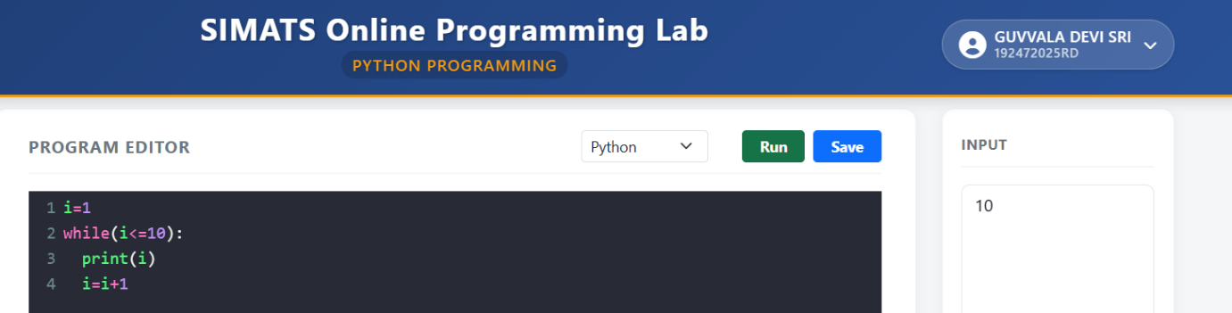
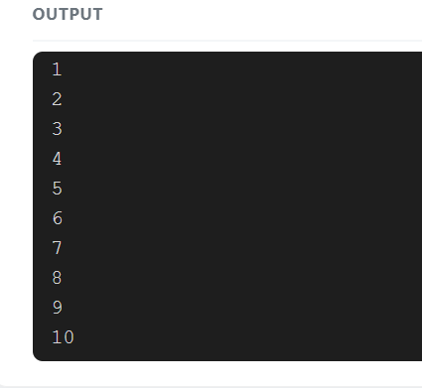

2.DISPLAY 10 TO 1
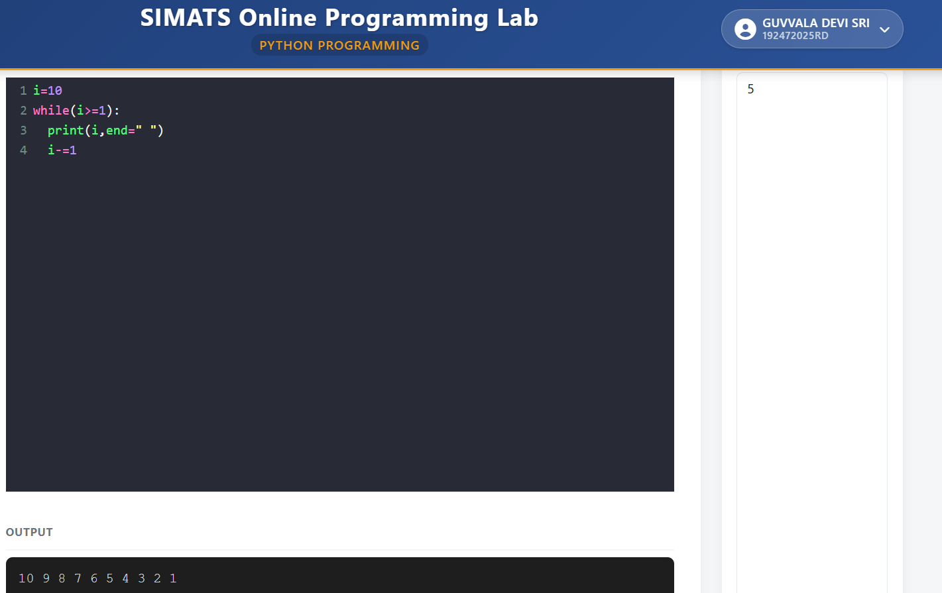

3.Display odd numbers from 1 to 20
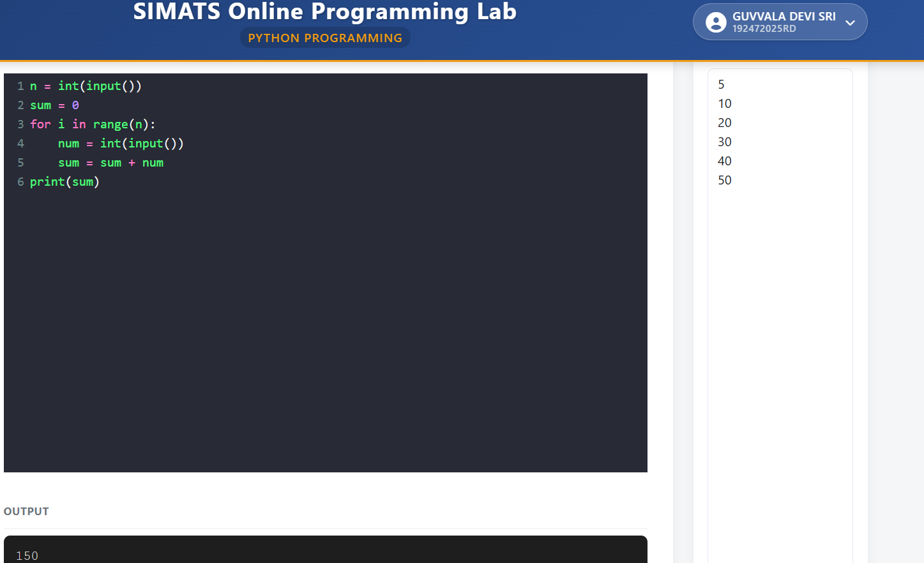

4.


5. Write a Python program to find the sum of even numbers from 1 to n.
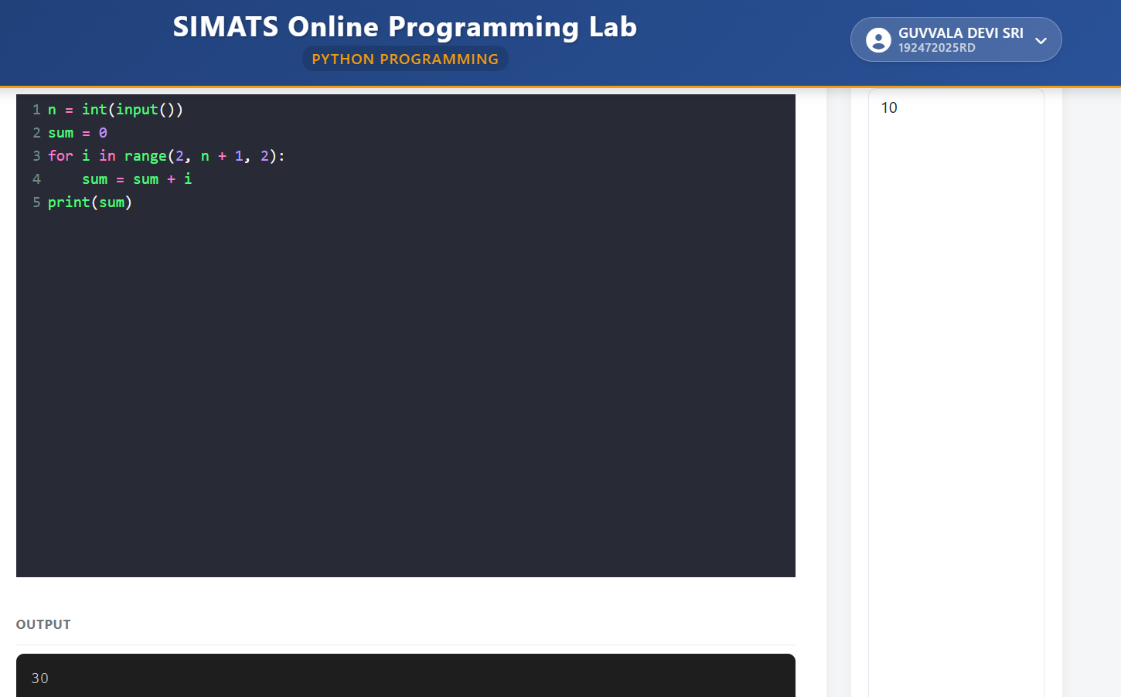

6. Write a Python program to find the factorial of a number.
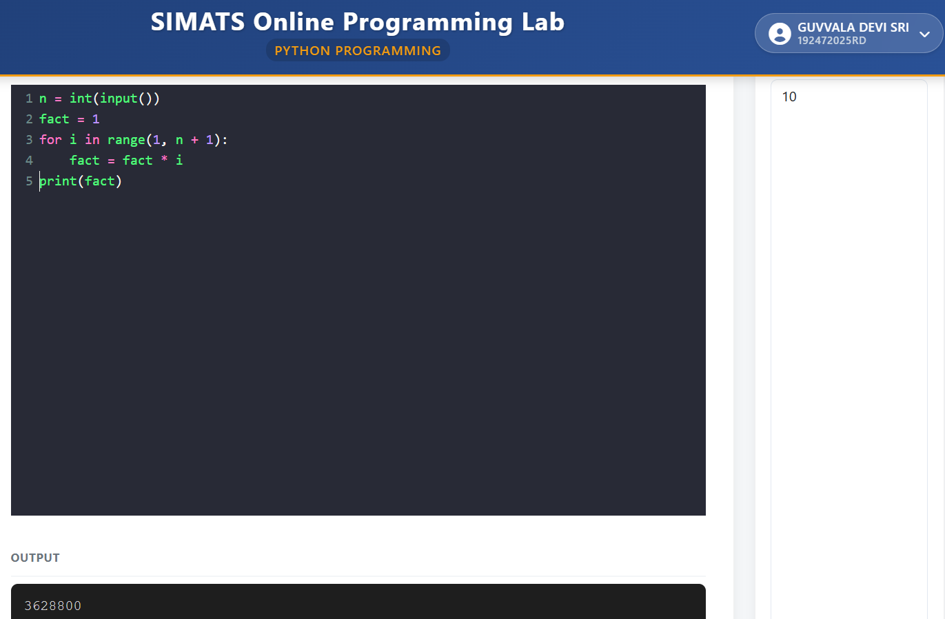

7. Write a Python program to print the Fibonacci series.
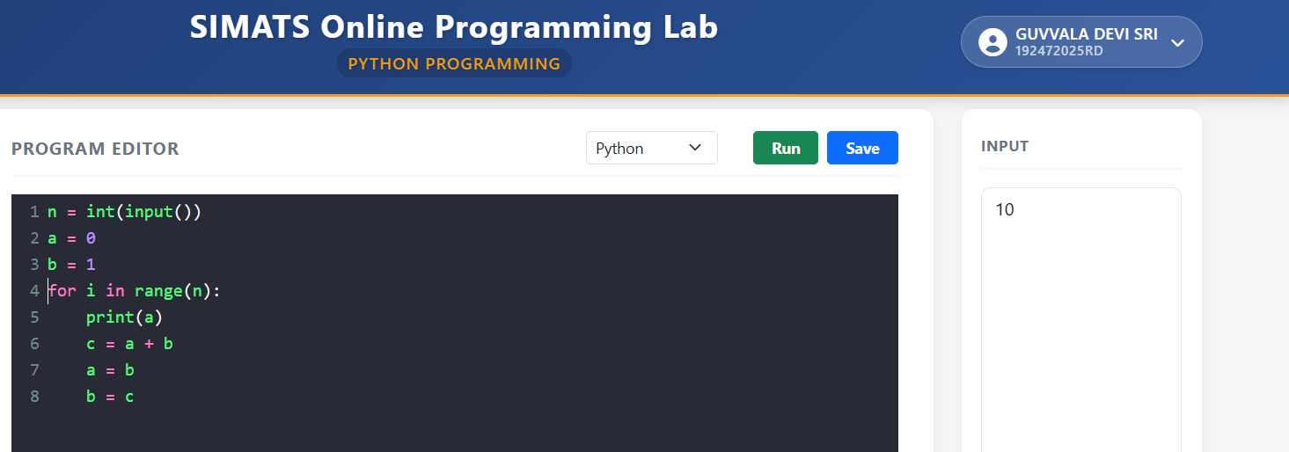
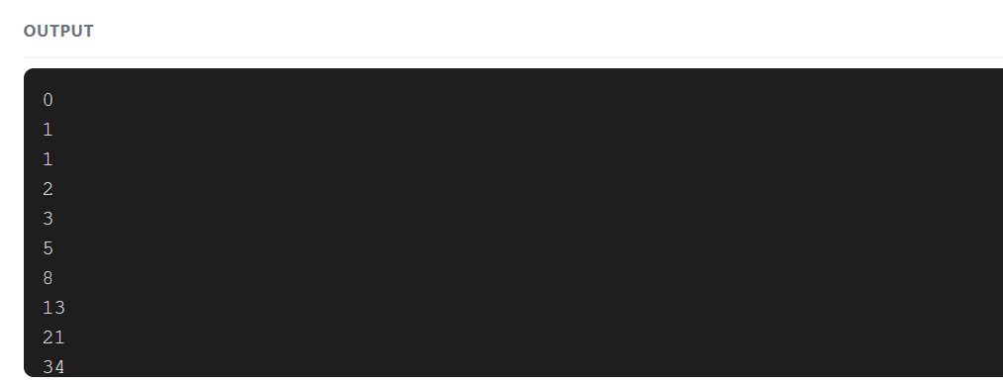

8. Write a Python program to find the sum of even Fibonacci numbers till n terms.
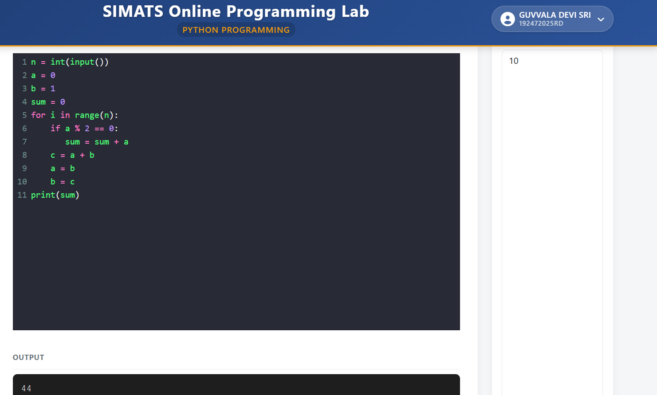

9. Write a Python program to find the sum of digits of a number.
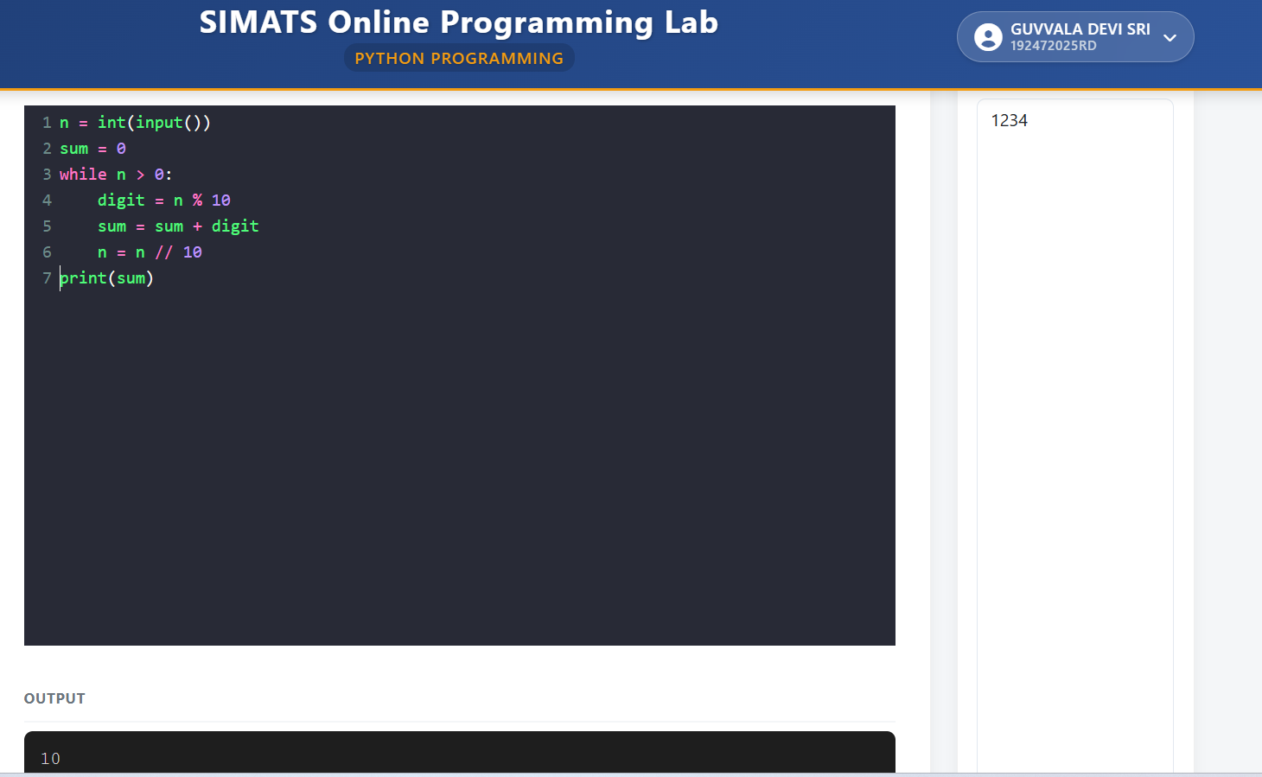

10. Write a Python program to reverse a given number.
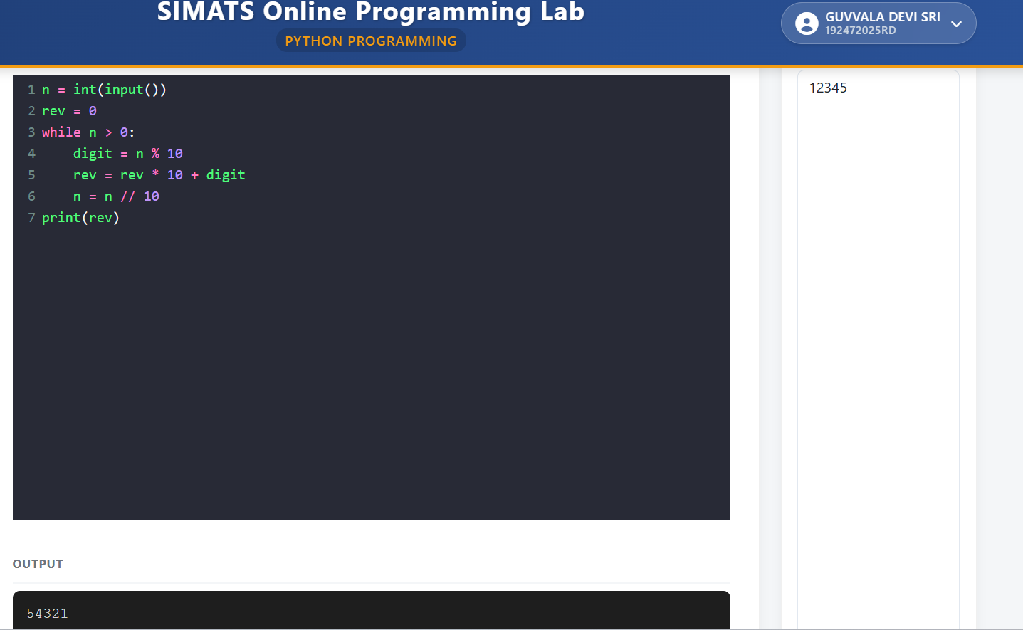

11. Write a Python program to check whether a number is an Armstrong number or not.
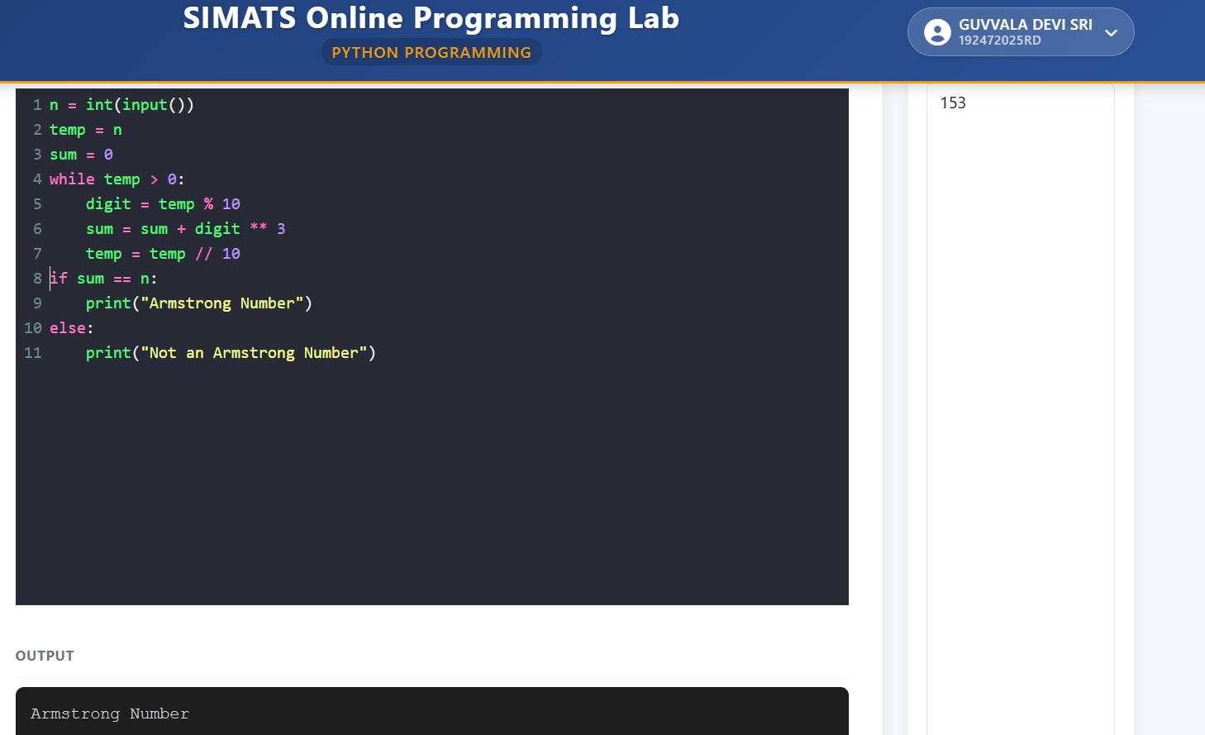

12. Write a Python program to check whether a number is a palindrome or not.